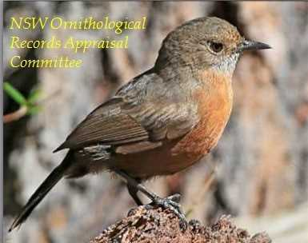 | NSW Ornithological Records Appraisal Committee  Unusual Record Report Form
This form is intended to aid observers in the preparation of a submission for the sighting of any species on the NSW ORAC Review List for NSW. (It is not a mandatory requirement) Please complete all sections ensuring that you attach all relevant information including copies of your notes, photographs or other supporting material, and forward by email to the Secretary, Roger McGovern at roglou@bigpond.net.au.
Section A: Submitter details
Your name(s)
Joint submissions are fine
Your email, phone and/or address

Section B: Record details
Common and scientific names
Include subspecies if relevant
Site location
(with GPS if possible)
Date(s) and time(s) of record
(First and last date of occurrence if known)
How many individuals were there?
What was the distance to the bird(s)?
Habitat description
Sighting conditions
(e.g. weather, visibility, light conditions)
How confident are you in the identification (as a %) and why?
Did you find and/or identify the bird initially? Who else recorded the bird and do they agree with the identification?
What experience have you had with this species?
Has this species been seen at this location before? When?
Have photographs of the bird or discussion of it occurred on the internet? (Please provide the site name, a summary, electronic link, etc.)
Do you permit NSW ORAC to display your images etc. electronically (credited with your name)

You may choose to delete or ignore this page, but please include as much of the requested information in your submission as possible, especially Sections C and E.
Section C: Supporting evidence
Please include evidence that supports the identification, such as photographs, video, call recordings, etc. Digital images can be pasted into this document below, at the end, or provided separately. Digital video and sound recordings can be sent separately to this form. Label photos etc or insert captions to make note of relevant features they show.

Section D: Description of the bird(s)
Please provide a description of the bird(s) including all identification features recorded.
Provide all possible details that might corroborate the identification.
Plumage
Bare parts
Moult details
Structure and ‘jizz’
Calls
Behaviours
Age, sex and/or taxonomy

Section E: Confusion species
Please indicate other species that the bird(s) might be confused with and how they can be eliminated

Section F: References and aids
Did you use books, journal articles or on-line sites or pages to help you prepare this submission? Which ones?
Would you like to acknowledge the assistance of others in the identification process or preparation of this submission?

